Selection sort
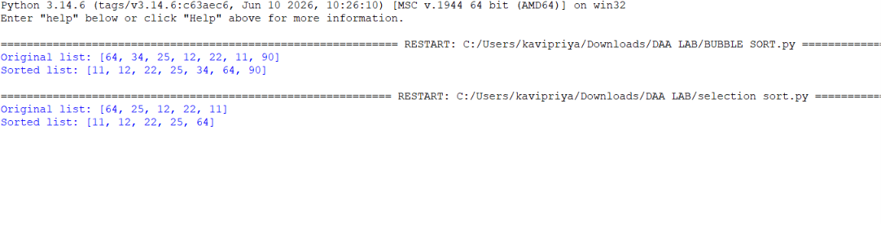
Code
def selection_sort(arr):
n = len(arr)
for i in range(n):
# Assume the first unsorted element is the minimum
min_index = i
# Find the smallest element in the remaining array
for j in range(i + 1, n):
if arr[j] < arr[min_index]:
min_index = j
# Swap the found minimum element with the first unsorted element
arr[i], arr[min_index] = arr[min_index], arr[i]
return arr
# Example
numbers = [64, 25, 12, 22, 11]
print("Original list:", numbers)
selection_sort(numbers)
print("Sorted list:", numbers)

